**How to Register a new Assessment?**

* To register a new assessment, Instructors and Service Providers will be required to use the “SwimSafer 2.0 Assessment Registration Form” on FormSG to register. The link for the form will be shared later.
* In the form, you will be required to indicate whether you are registering for an Assessment or to Add-On additional students to an existing Assessment, before proceeding to fill up the information.

***If registering new Assessment:***

* Indicate whether you are registering for a public or MOE Assessment.

**Public Assessment selected:**

* If you have selected that you are registering for a Public Assessment, you will be required to fill up the following details:

For field 10, you may choose to upload the student’s Namelist via Manual Key-In or Namelist upload.

**Manual Key-In**

Fill up the fields accordingly using the table as shown below. Service providers will be able to add in more rows as needed.

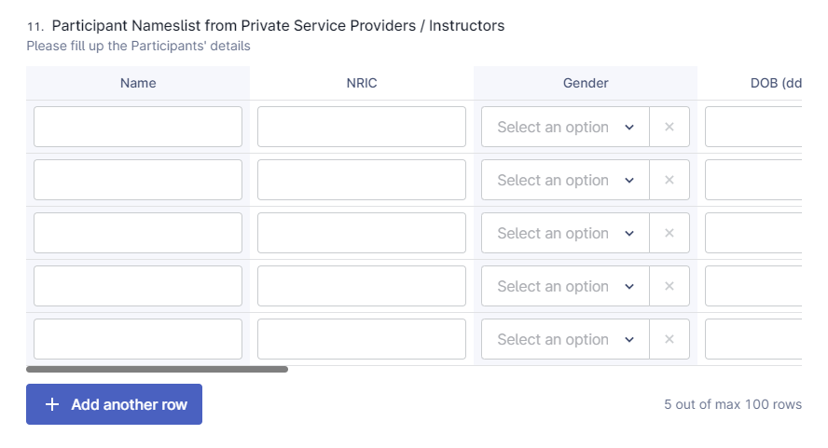

**Namelist upload**

Service providers can choose to upload the Namelist using a provided template that can be found [here](SwimSafer%20Assessment%20Particpant%20registration%20template%20(Private)-2.xlsx). 

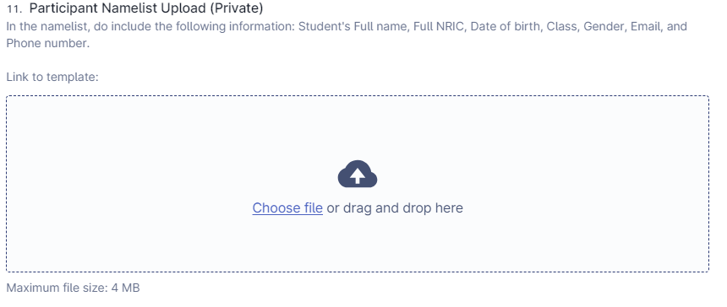

**Key Points:**

* The Service Provider/Instructor can choose to either manually input student information or upload an Excel sheet with the required format (instructions found on 1st tab of the template)
* Submitting accurate participant information and assessment details in the assessment registration form is crucial to ensure we can match the data.

**MOE Assessment selected:**

* If you have selected that you are registering for a MOE Assessment, you will be required to fill the following details:

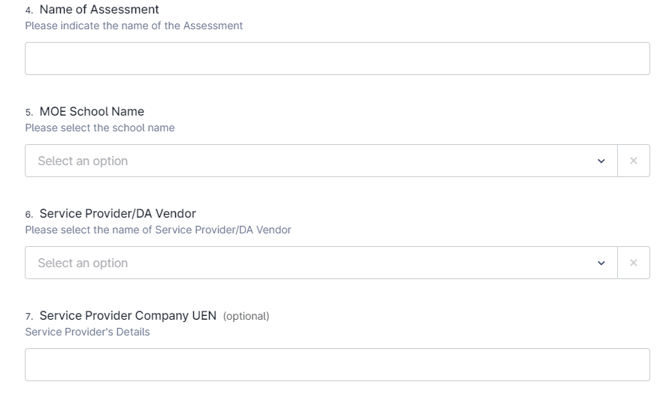

**Namelist upload**

Service providers can choose to upload the Namelist using a provided template that can be found here. 

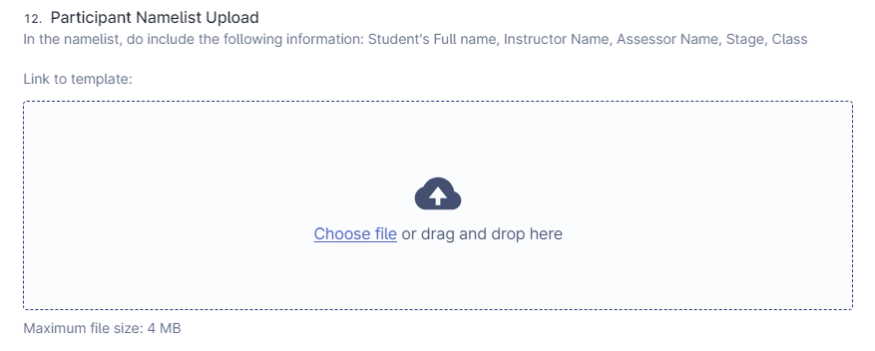

**Key Points:**

* The school must input students' information into the Excel namelist using the specified format: Full Name, NRIC, Date of Birth, Gender.
* Submitting accurate participant information and assessment details in the assessment registration form is crucial to ensure we can match the data.

**Declaration**Proceed to check the boxes under the Declaration field below.

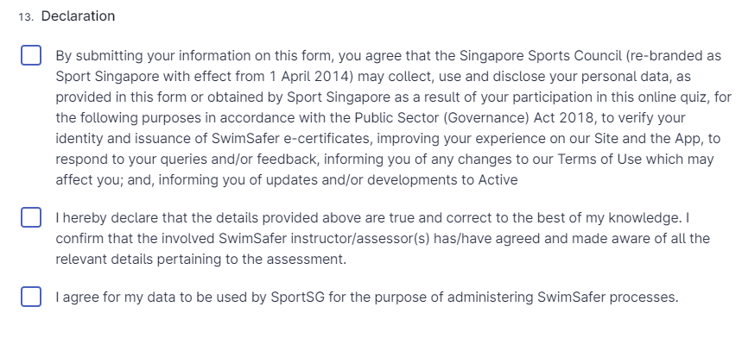

**Payment (Assessment Registration)**For new Assessment registration payment, select “SwimSafer Assessment – Participant Registration Fees” and proceed to select the correct quantity (Qty) according to the number of participants registered. A close-up of a registration fee  
  
  
  
**Please ensure that amount indicated and paid matches the number of participants registered for the assessment. Incorrect payments will not be processed until the correct amount is reconciled. For example, if you uploaded using csv namelist for 10 participants, total amount is $100**

**Add-On**

If you are filling up the form for Add-On, you will be required to fill up the following details regarding the assessment:  
  
For MOE:

For Public:

**Payment (Add-On)**

For “Add-On” payment, select “(Top-up Only) SwimSafer Assessment - Additional Participant Registration Fee” and proceed to select the correct quantity (Qty) according to the number of participants registered.  
  
**Please ensure that amount indicated and paid matches the number of participants registered for the assessment. Incorrect payments will not be processed until the correct amount is reconciled by SwimSafer Admin. (For example, if you submitted additional namelist for 2 participants, total amount is $20)**