ANNEX A – NEW SPEXSCHOLARS

 | Sport | Name | Key Achievements
 | Athletics | Shanti Pereira  (26 y/o)  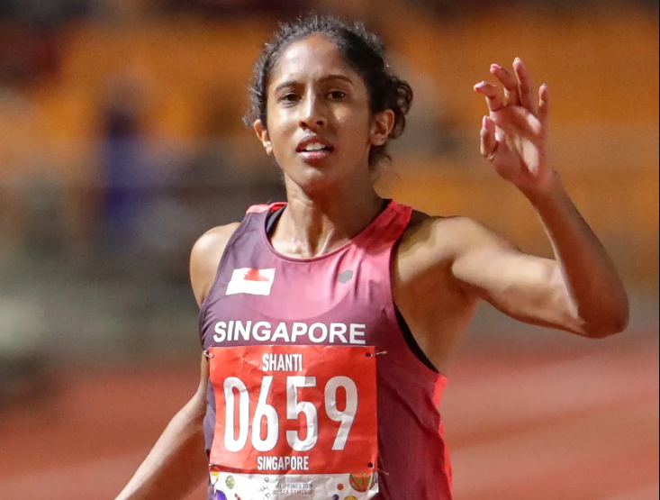 | - 2022 World Athletics Championship (200M) – 23.53 (Heats)  - 2022 Commonwealth Games (200M) – 23.46 (Semi-Finals – 11th out of 24)  - 2022 Commonwealth Games (200M) – 23.46 (Heats – 10th out of 36 – PB+NR)  - 2022 Commonwealth Games (100M) – 11.57 (Heats – 20th out of 24)  - 2022 Commonwealth Games (100M) – 11.48 (Heats – 21st out of 49 – PB+NR)  - 2021 SEA Games – Gold (200M Finals – 23.52 – PB+NR)  - 2021 SEA Games – Silver (100M Finals-11.62- PB+NR)
 | Badminton  (Mixed Doubles) | Terry Hee (27 y/o) & Tan Wei Han (29 y/o)  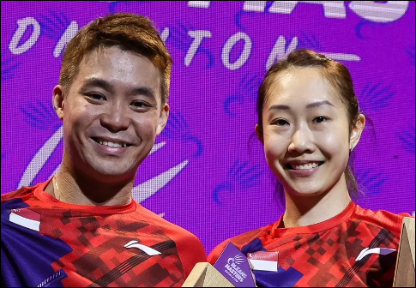 | - 2022 Orleans Masters (Super100) – Champion  - 2022 India Open (Super500) – Champion  - 2021 Czech Open (International Series) – Champion  - 2021 Belgian International Challenge – Semi-Finalists  - 2021 Dutch Open (International Challenge) – Semi-Finalists  - 2022 Commonwealth Games – Champion
 | Badminton  (Women Doubles) | Jin Yu Jia (25 y/o) & Crystal Wong (23 y/o)  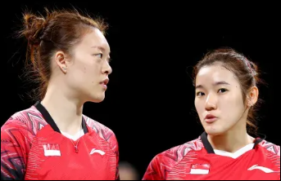 | - 2022 BWF World Championship – R16  - 2022 Denmark Masters (IC) – Silver Medallists  - 2022 Italian International (IC) – Silver Medallists  - 2022 Korea Open (S500) – Quarter-Finalists  - 2022 Estonian International (IS) – Semi-Finalists  - 2022 Commonwealth Games – Women Doubles Quarter-Finalists
 | Fencing | Cheung Kemei  (17y/o)  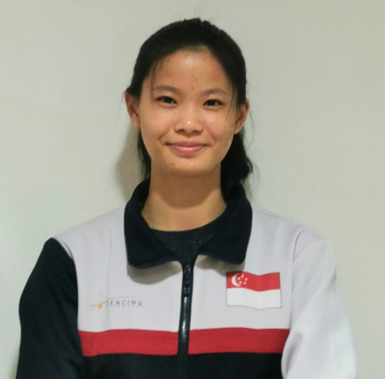 | - 2022 Guadalajara World Cup – Women’s Individual (109th/143)  - 2022 Guadalajara World Cup – Women’s Team (15th/17)  - 2022 Belgrade World Cup – Women’s Individual (64th/170)  - 2022 Belgrade World Cup – Women’s Team (8th /20)  - 2022 Tauber World Cup – Women’s Individual (52nd/189)  - 2022 Tauber World Cup – Women’s Team (19th/22)  - 2021 SEA Games – Women’s Individual (3rd/12)  - 2021 SEA Games – Women’s Team (1st/6)  - 2022 Asian Fencing Championships – Women’s Individual (14th/42)  - 2022 Asian Fencing Championships – Women’s Team (4th/10)
 | Shooting | Fernel Tan  (19 y/o)  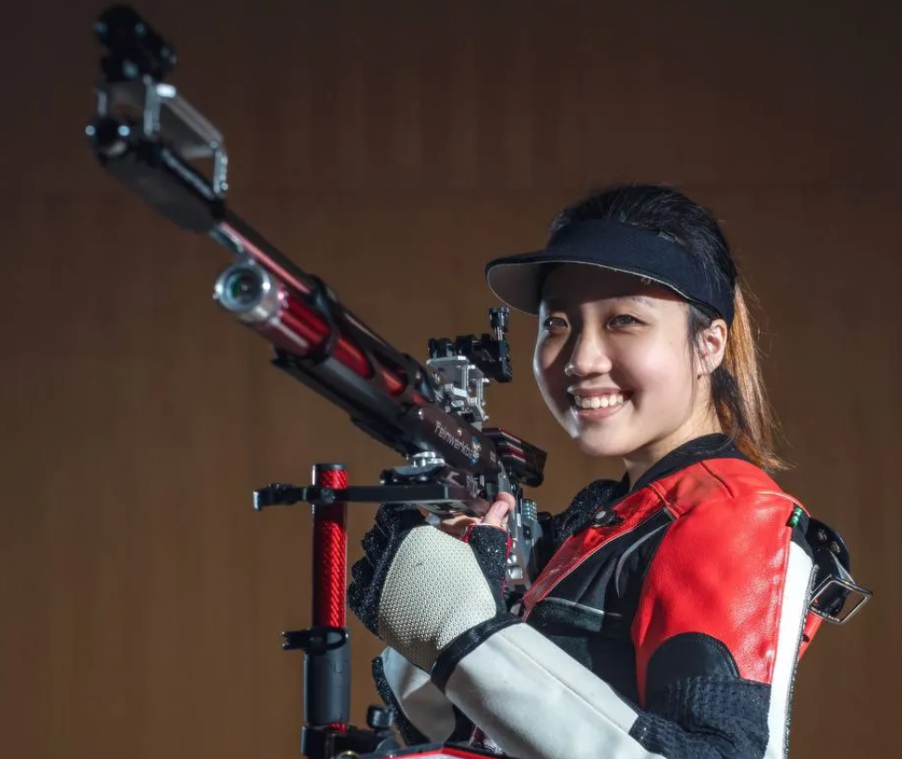 | - 2021 SEA Games – 10m Air Rifle Women Team, Bronze  - 2021 SEA Games – 10m Air Rifle Mixed Team, Silver  - 2022 ISSF World Cup Cairo – 10m Air Rifle Women Team, Bronze  - 2022 ISSF Grand Prix Jakarta – 10m Air Rifle Women Team, Gold  - 2022 ISSF Grand Prix Jakarta – 10m Air Rifle Mixed Team, Silver

